Project Design Phase-II
Data Flow Diagram & User Stories

Date | 31 January 2025
Team ID
Project Name
Maximum Marks | 4 Marks

Data Flow Diagrams:
A Data Flow Diagram (DFD) is a visual representation of how data moves through the AI Weather Wise system. It shows how weather data is collected from external sources, processed and analyzed by the system, stored when required, and delivered to users as weather forecasts, alerts, and recommendations.
It helps explain the flow of information between users, weather data sources, processing components, databases, and the final weather information presented to users.
Example: (Simplified)
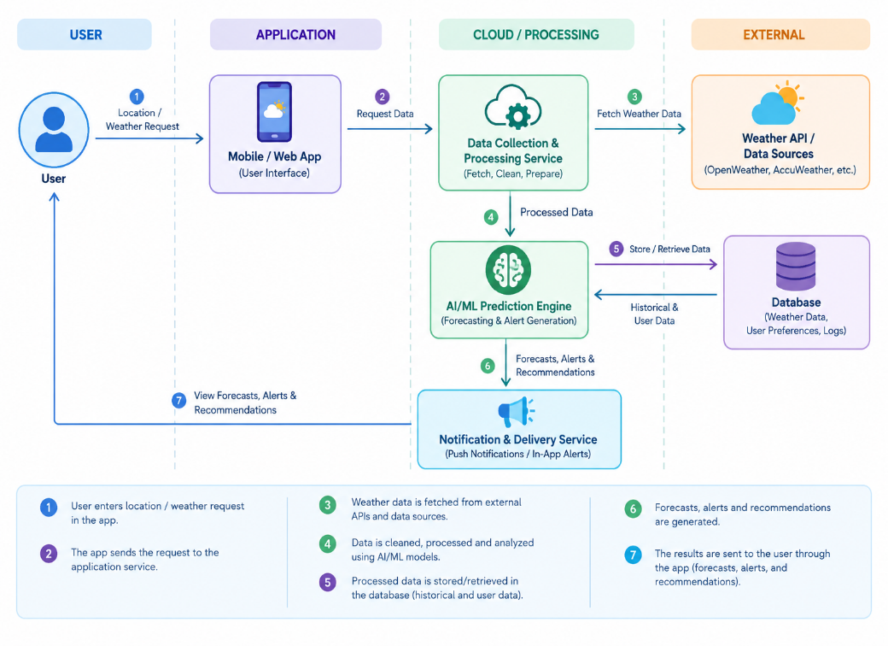
Example: DFD Level 0 – Weather Forecasting System
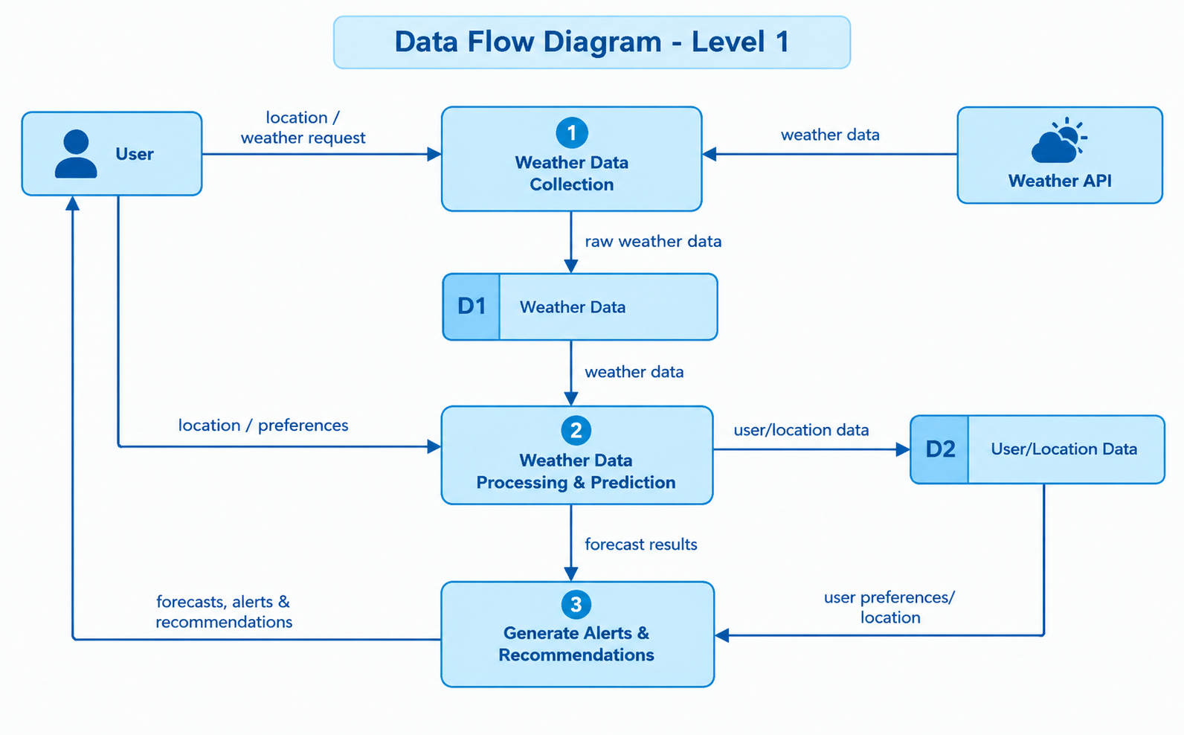

User Stories
Use the below template to list all the user stories for the product.
User Type | Functional Requirement (Epic) | User Story Number | User Story / Task | Acceptance Criteria | Priority | Release
Customer (Mobile/Web User) | Registration | USN-1 | As a user, I can register using my name, email and password so that I can access the application. | User can successfully create an account and access the dashboard. | High | Sprint-1
Customer (Mobile/Web User) | Login | USN-2 | As a user, I can log in using my registered email and password. | Valid credentials allow the user to access the dashboard. Invalid credentials display an error message. | High | Sprint-1
Customer (Mobile/Web User) | Location | USN-3 | As a user, I can enter or select my location to receive weather information for my area. | The selected location is displayed and weather information is provided for that location. | High | Sprint-1
Customer (Mobile/Web User) | Weather Forecast | USN-4 | As a user, I can view the current weather conditions and forecast for my selected location. | Temperature, weather condition, humidity, wind and forecast information are displayed correctly. | High | Sprint-1
Customer (Mobile/Web User) | Weather Forecast | USN-5 | As a user, I can view the weather forecast for upcoming days. | The application displays the forecast for the available upcoming days. | High | Sprint-2
Customer (Mobile/Web User) | Real-Time Weather Updates | USN-6 | As a user, I can receive updated weather information when weather conditions change. | The displayed weather information is refreshed with the latest available data. | High | Sprint-2
Customer (Mobile/Web User) | Extreme Weather Alerts | USN-7 | As a user, I can receive alerts about severe weather conditions such as heavy rain, storms and heatwaves. | An alert is displayed when a relevant severe-weather condition is detected. | High | Sprint-2
Customer (Mobile/Web User) | Recommendations | USN-8 | As a user, I can receive recommendations based on the current and predicted weather conditions. | The system provides relevant recommendations such as carrying an umbrella or avoiding outdoor activities during severe weather. | Medium | Sprint-2
Customer (Mobile/Web User) | Weather History | USN-9 | As a user, I can view previously recorded weather information for my selected location. | Historical weather information is displayed in an understandable format. | Medium | Sprint-3
Customer (Mobile/Web User) | Multiple Locations | USN-10 | As a user, I can search for weather information for different locations. | The user can search a location and view its corresponding weather information. | Medium | Sprint-3
Customer (Mobile/Web User) | Notifications | USN-11 | As a user, I can receive notifications for important weather warnings. | Notifications are sent/displayed when important weather alerts are generated. | High | Sprint-3
Administrator | Weather Data Management | USN-12 | As an administrator, I can monitor the weather data received from external weather sources. | The administrator can view the status of incoming weather data. | Medium | Sprint-3
Administrator | User Management | USN-13 | As an administrator, I can manage registered user accounts. | Administrator can view, update or deactivate user accounts when required. | Medium | Sprint-4
Administrator | Alert Management | USN-14 | As an administrator, I can monitor weather alerts generated by the system. | Generated alerts can be viewed and monitored by the administrator. | High | Sprint-4

